Decision Analysis and Support -February 2022

Ken McNaught~Centre for simulation and Analytics

* Background is operational research in Pidd’s term “management scientist”.
  + **A central idea of Pidd’s book:** One distinguishing characteristic of management scientists (meaning operational research professionals, business analysts and others who use rational and logical methods) is their use of explicit models(Pidd, 2009, p. 8).
  + UK and US OR started at the same origins. Applying quantitative methods to military problems after WW2.
* Operations research~Pidd uses “management science” term.
* Origin, USA, UK, Applying quantity methods to military problems şn the WW2
* Afrter 1980s UK is also take the line using modelling to think through soft problems.
* The aim of the module is to introduce a range of modelling approaches which can improve support to decision makers as well as enhancing the auditability and traceability of their decisions.
  + Models are tools to think with.
  + Models give explicit set of assumptions.
* ILOs:
  + Evaluate a range of modelling approaches and their suitability for different problem types.
  + Construct and analyse a range of models to represent problem situations and support related decision-making.
  + Distinguish between different decision types and their relationship to uncertainty and risk.
  + Explain the role of trade-off and its impact on decision making and outcome.
  + Describe cognitive biases which are relevant to decision making and their effects.

**Unit 1: Introduction**

* Decision analysis:
  + Not mean to make decision for decision makers. Some AI functions do this in low level problems.
  + It provides tools to think through the problem.
  + Provides support and advice to decision maker.
* The principal aims are to help decision makers:
  + explore the problem situation or opportunity: help decision makers think through problem situation in a structured way.
  + learn about their own and others’ values and judgements;
  + identify a preferred course of action consistent with their beliefs.
* The most useful approaches are conceptually simple and transparent.
* The process leads to better considered, more justifiable and explainable decisions.
* Elements of a Decision Problem: Decision Analysis involves
  + *Alternatives:* nature of alternatives vary depend on type of decision problem.Shelf options that we can buy. Aircraft, tank, or which tank? Some problems have finite alternatives, and you develop better alternative.
  + *Values:* The things that we care about. With any alternative what we hope to achieve. Goals, objectives we want. If we want a equipmenthat we want it to achieve. Value is central to choise in any decision problem.
  + *Preferences:* we need methods that allows us lay preferences between alternatives.
  + *Uncertainties:* depend on context, nature of decision problem.
* It offers a range of structured and coherent approaches to balance these various aspects of a decision problem.
* Origins of DA
  + Ron Howard, of Stanford University, coined the term in 1966, in his paper ‘Decision Analysis: Applied Decision Theory’.
    - Decision theory term is longer, statistical decision theory, existed but Ron thought this is not comminicating effectively with decision makers. He thought decision theory is much more practical. He made it usable in everyday situation. Change from abstract theoretical area to practical.
  + He later said that he had almost used the term ‘Decision Engineering’ instead, but felt this sounded manipulative.
    - Engineering an outcome idea has bad connotations.
* **What is Decision Analysis?**
  + ‘Decisions are easy, it’s the rationale that’s difficult’ – Anonymous
    - Rationale-Justification is needed for big decisions
  + … a systematic procedure for transforming opaque decision problems into transparent decision problems by a sequence of transparent steps… Howard (1988, p680)
  + Decision analysis helps to provide a structure to thinking, a language for expressing concerns of the group and a way of combining different perspectives. Phillips (1990, p150)
    - Whatever the field is, the underlying structure of decision problems are same.
    - This feature allows these tools is used across different fields. They are common language.
* Tools:
  + Decision trees: useful for sequential decision forms. Good for highlighting decision points within the control of decision maker. Useful also for chance and uncertainties (consequences and choices) that are out of control.
  + Influence diagrams: similar but compact representation of decision problem. Develop by ron and his collegue Jim.
  + Partial value tree: highlighting diagramatically the value we attribute to criteria to dwell on. SMART is particular method.
* **Rationality and Bounded Rationality**
  + Normative and prescriptive DA use the concept of a ‘rational’ decision-maker, implying a consistent and logical outlook.
  + Some have criticised normative DA methods for not providing good descriptions of how people actually make decisions. However, that is not their purpose.
    - Psychology side criticised DA methods for not providing good descriptions of how people actually make decisions. That miss the point. These methods says how we make decisions if we accept some basic reasoning axioms. These axioms primarily concern with consistency. If we consistent on our thought they help to lead us to a particular alternative. If we dont use tools and rely on gut instinct the way we do personnaly, come up with intuitive decision-psycholgy explains this-descriptive DA. NATURALİSTİC DECİSİON MAKİNG. RPD, Recognition
  + Normative and prescriptive approaches are concerned with how we ought to decide if we accept some basic reasoning axioms.
  + In fact, humans are much better described as having ‘bounded rationality’, a term coined by Herbert Simon in the late 1950s. Founder of AI
  + It alludes to: we suffer from many unconscious cognitive biases (not we aware of) which detract from our ability to reason rationally.
    - Human brain limits in computation. We use compter.
    - Same is true in decision problems. There are different factors, numbers, some relevant some not. Brain cannot come to sensible rational decision. Use decision support aid or tool to help us think through the decision that a bit more rational.
* Prescriptive vs Descriptive Decision Analysis
  + **Descriptive** DA is concerned with how people actually make decisions and is largely in the realm of psychology.
  + **Prescriptive** DA is concerned with helping or supporting decision-makers to make the ‘best’ decision that they can given their (consistent with) beliefs and preferences. It does this by combining the available information with their honest judgement while trying to avoid cognitive biases. This is the type of decision analysis that we will be dealing with.
    - Process is transparent but it is still difficult to pin down beliefs and preferences.
    - Takes into account that we are limited in cognitive abilities.We suffer from biases.
    - ‘This approach prescribes how an individual who is faced with a problem of choice under uncertainty should go about choosing a course of action that is consistent with their personal basic judgments and preferences. They must consciously police the consistency of their subjective inputs and calculate their implications for action. Such an approach is designed to help us reason and act a bit more systematically – when we choose to do so!’ Howard Raiffa (1968), Decision Analysis: Introductory Lectures on Choices under Uncertainty
* Example Application - MANPADS
  + A decision tree model to investigate the costeffectiveness of MANPADS countermeasures. For possible threats from terrorists who may employ them to civilian airlines.
  + These are electronic systems that can be fitted to airliners to counter terrorist-launched SAMs.
  + Study by von Winterfeldt and O’Sullivan (2006) for the US Dept of Homeland Security
    - Show how to get decision with small model
    - Combines info are hard, estimates of success of a hit from manpads with softer, subjective info: Probability of attack of this type in a ten year time.
* Example Application - US Army Base Realignment and Closure Programme
  + A major study making use of MCDA to advise on the use and closure of US Army bases.
* **Judgement**
  + In developing any kind of model, some degree of judgement is required. Scope of model, subjective probabilities, how likely is attack on airliner.
  + Sometimes this is limited to judgements required of the model builder but often the judgements of subject domain experts are required.
  + In developing decision analytic models, we often have to elicit such expert judgements, e.g. to provide probabilities of chance events and forecast values associated with various outcomes or consequences.
* The Nature of Models
  + When interpreting the outputs of decision analytic models, both analysts and decisionmakers should bear in mind the well-known maxim which applies to every type of model:
  + ‘All models are wrong but some are useful.’- George Box
  + He alludes that models includes simplifications, it can’t include everything, decision maker is ultimate person to decide, he can take advice from model, aware that models have limitations. Combine model withown judgements.
  + Decision Analysis does not make decision maker redundant.

**Unit 2: Models and Modelling Sean Price, Cranfield University**

**What is model?**

* Motivation
* Why do we model?
  + Understanding
  + Decision support
  + Communication: Interacting with world. You think and you model thoughts with letters to represent.
  + Others?
* What do we model?
* do we (formal side of modelling)
  + Build them?
  + Use them?
  + Have confidence in them? Don’ confuse, it does not take decision. It helps think through.
  + Create confidence in them?
  + Communicate them?
* Modelling is supported by concept of modelling and simulation:
  + "*The field of modeling and simulation (M&S) is as diverse as the concerns of man. Every discipline has developed, or is developing, its own models and its own approach and tools for studying these models*." (Taken from Zeigler, Theory of Modelling and Simulation, Intro)
  + It is prevalent in all aspects of thinking. You do modelling in every field.
* Modelling is everywhere…It is something that we do all time.
* Indeed, how do we address the world without models?
* We all use models daily:
  + Sometimes explicitly
  + Often implicitly
  + Often without realizing
* **A model is a**
  + Representation of something (reality).
    - Something that we are interested in…
    - For some reason…
  + It is in some sense an abstraction I’ve led something out.
  + Strongly related to notion of purpose.
* Example – Ordnance Survey Map good example of modelling. We have
  + Subject
  + Conventions, I can communicate using this model. Many data buried in this model by convention.
    - Red line means particular type of road.
    - Brown line indicate terrain height.
    - Blue lines square show the grid system, gives us scale.
  + Symbols
  + We are abstracting out something that is of interest (part of earth in wiltshire).
  + Important to understand what the model can be used or cannot be used. Sort of confidence interval. Utility: useful to use or not.
  + Experiment with model: quickest way to get A to B.
  + Abstraction:0020We have to leave out things in order to create models.in order to represent something much clearer. Capture the essence of what you’re trying to think about from your particular perspective.
  + 
* Overground model of train:
  + Representational, not used to see underground. Topological representation.
  + It is representative on the surface.
  + Useful model tecnician going in between stations.

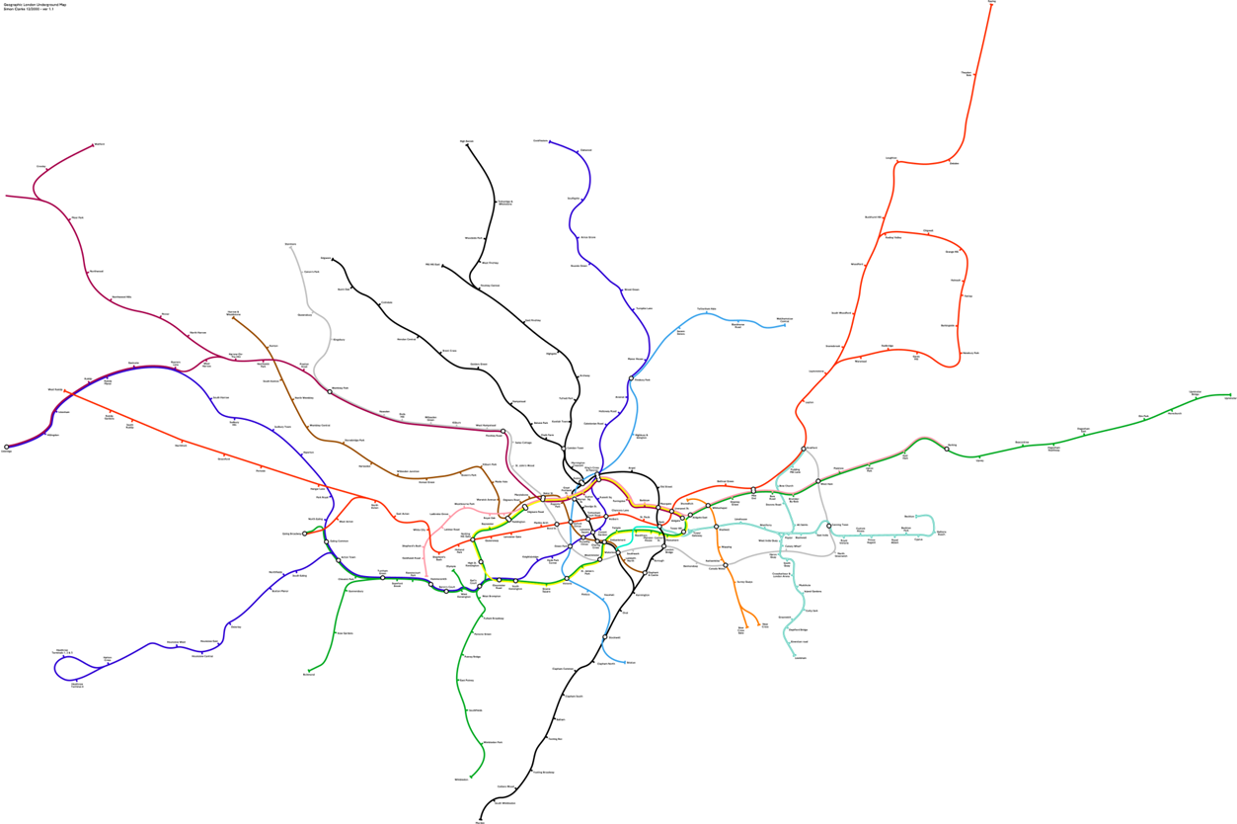

* We used to see this: topologically equivalent to the previous. But simplified, distances are shrunk to make nice picture. Useful to use underground. I am not worried about distances I am worried about how to find correct line. **Notion of purpose** comes strongly.
  + Useful model for commuter

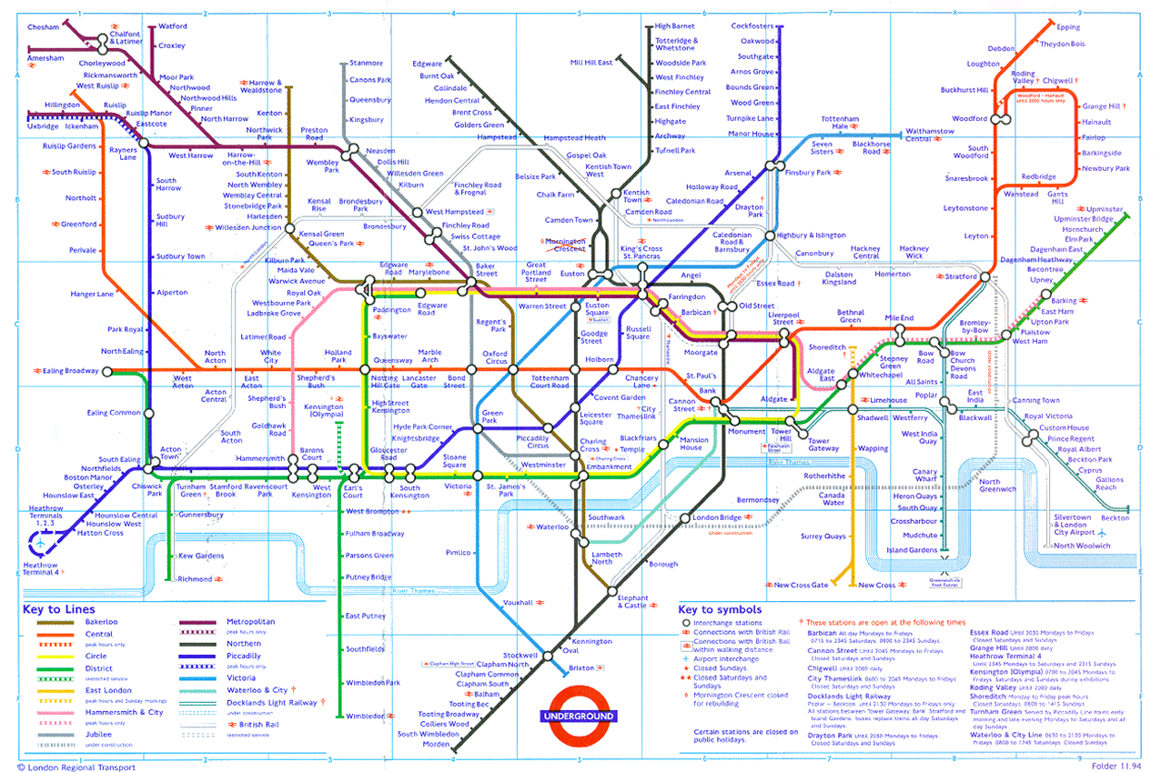

* When you construct model think of 3 things: **What is a Model? A more formal view** (Ludewig, 2003)
  + They describe a thing (**Mapping Criterion**)
    - Original object or phenomenon that is mapped to the model. Should be tangible or not (political system).
  + As an abstraction (**Reduction Criterion**)
    - Not all the properties of the original are needed; this is the real strength of models.
    - “Generalisation; ignoring or hiding details to capture some kind of commonality between different instances”.
    - Sort out what you can safely abstract out.
  + For a reason (**Pragmatic Criterion**)
    - The model is useful, i.e. can replace the original for some purpose.

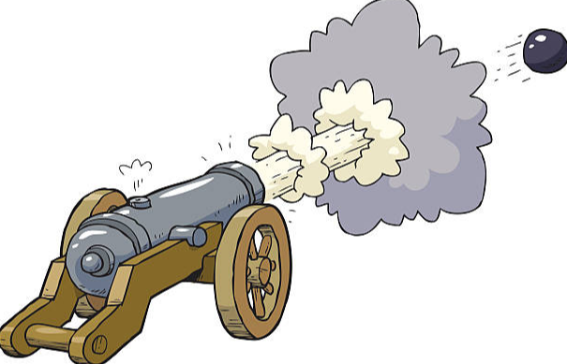

This can be good for a particular purpose: model using Newtonian physics, basic dynamics to look as shell trajectory where it might land if I fire it particular elevation on a charge.

**Modelling Cycle**

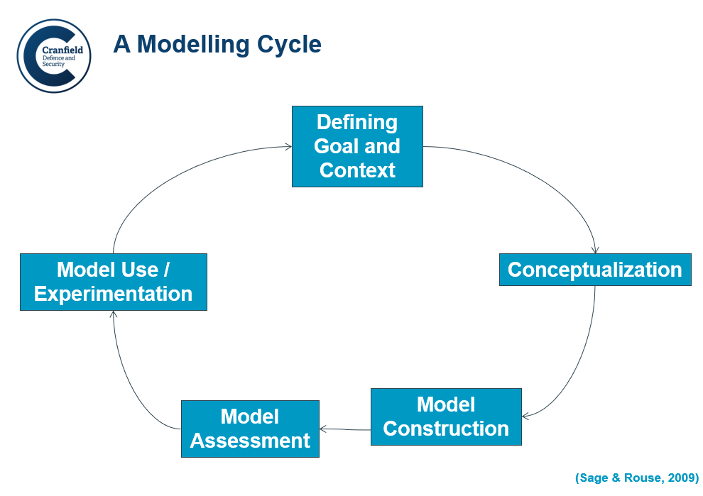

We dont trivilaise the relationship between real life and model. We have to continually test that.

* **Defining goal and context:** 
  + Everybody has own perceptions. Mental models of the world. They are the one we will interface. We percieve world through models. Baby creating own reality based on perceptions around it. You talk to baby, say hand, f,nger etc. All these are modelling activities. We are creating mental models that makes sense to us. Model allows us to relate to the world.
* **Conceptualizing:** 
  + Having these peerceptions, we conceptualize those in some way. Try to sort out key components in relation to our particular purpose. We develop a construct.
  + This involves biases. Because we relate that to our own understanding. World is a flat was perception for a while. So you would go edge of world if you sail west.
  + Try to overcome that. Come up with defensible, be clear where the buyers might exist.
    - “I think ***it’s very important that we have to acknowledge that we can never take an objective view about evidence***. We always bring our, I think, personalities into it, and mine is unfortunately very optimistic and that’s why I’m very glad I’m not a government adviser. I don’t think I’d be very good at it because I do tend to hope for the best and sort of expect the best as well.” *Statistician Sir David Spiegelhalter* (who did not take covid seriously).
    - We use all data, mechanics etc. in some sense. Mental baggage prevents us from taking an objective stance. I’am a glass half-full guy.
  + It can be whiteboard exercise, flipchart, blueprint, computer model
* **Model assessment:** 
  + Once we build model we start to use it.
  + We built it to think with (Pidd)
  + In order to use it we need to be sure that we built right. And it is a valid representation. If we did not do correctly we have invalid rep of reality.
* Experimentation:
  + If we assess our model to be valid, we can experiment it.
  + Use the model carefuly. We don’t go outside or bounds of the validity of the model. We cannot know any further detail than map tells us. Walk from station to church.
* There is a rep and num of people. Stakeholders, modeller. Ops planning is modelling activity, the people who do it for need to understand exactly what it is you require and what you wanna do with the model. Communicating the thought in a clear way to stakeholder is key.
* **A Simple Modelling Example – What elevation to achieve a certain range?**
  + Trigonometrie and math is developed iot allow artillery to successfully hit the targets in Napoleon time. Math employed in battlefield.
  + How we may abstract?

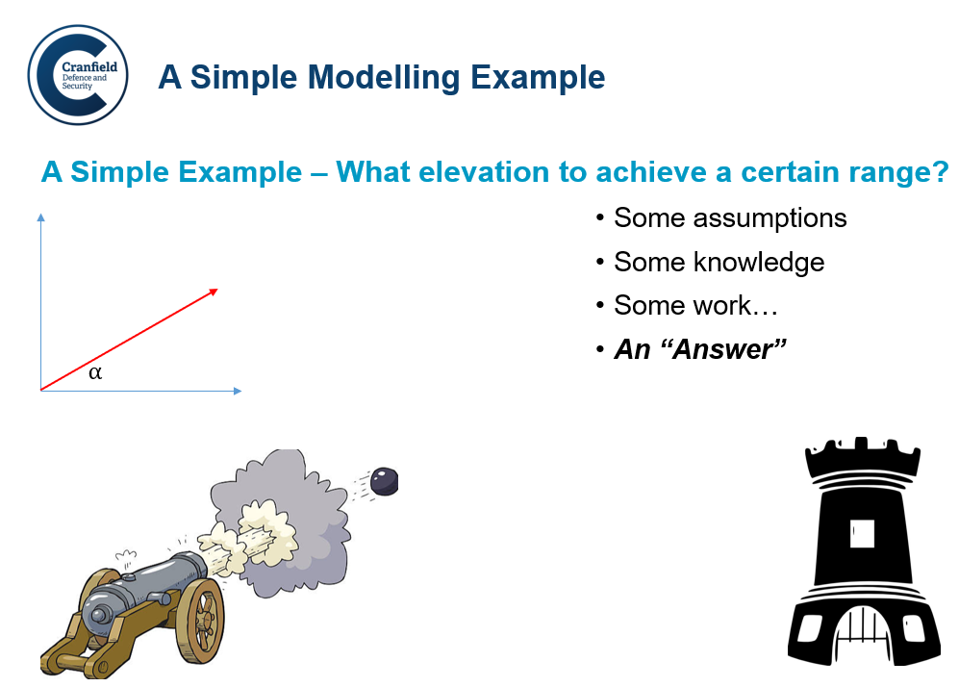

Think what is important. We have a barrel. Pointing certain direction in 3 space. Assume 2 spcae, makes certain angle-up; based on the knowledge of exit speed of projectile, gravity, with newtonian physcis we can get answer. Where it will land given exit velocity and elevation angle. And grativational constant. Answer is consequence of the model. How do we know it relate to reality? test it. We can have a degree of confidence whether it is good or bad answer.

* **A Simple Modelling Example**
  + Problem – Setting elevation of a cannon to hit a target at certain range
  + Assumptions and Data – Cannon firing a ball, elevation angle, barrel exit speed, gravitational force, air resistance, ...
  + Model – Simple dynamics model:
    - With basic formula you solved it. İt was deterministic. There is no probability. Sometimes it is comlicated.
  + Interpretation Methods
    - Analytical
    - Numerical
    - Simulation (essentially, computer based numerical) running a model overtime.
  + Simulation
    - Equations satisfied, allowed outcome
    - Not satisfied, disallowed outcome
  + Exclusion Law
  + If speed of wind and terrain factors in then we have a chance factor in. The more complicated we build our model more likley it will be stochastic. It will not have a single determined outcome. Outcomes vary according to some probability distributions. We create space of things that allowed to happen in model and things that cannot happen. Care about space of possibility maps on the real world.
* **The Conceptual Model and the DDI Account**
  + DDI approach invites us to think of a theoretical representation in terms of three components: Denotation, Demonstration, and Interpretation.
  + Elements of the subject of the model (a physical system evincing a particular kind of behaviour)
    - ***denoted*** by elements of the model (like exit velocity in gun).
    - the internal dynamic of the model then allows conclusions- consequences to be ***demonstrated***.
    - these conclusions can then be ***interpreted*** in terms of the subject of the model. Morrison. (1999), p.125.
  + We know model now. What does it say about real world? What we have confidence in? (It doesn’t give decision but helps you to get best decision, you have confidence and it allows to make better decision. Utility is if model makes you confident)
* "Perhaps the key philosophical question regarding the nature of models concerns their connection to concrete physical systems and the degree to which they enable us to draw conclusions about these systems". Morrison
* Leap of faith is the relationship between the model and reality:
* 
* Developed from ideas in “Models as Mediators: Perspectives On Natural And Social Science”, Edited by Mary S. Morgan and Margaret Morrison, Chapter 5 "The Ising Model, Computer Simulation, And Universal Physics", R. I. G. Hughes.

**Problem types**

Well-defined problems; Wicked problems; Agreement and perspective

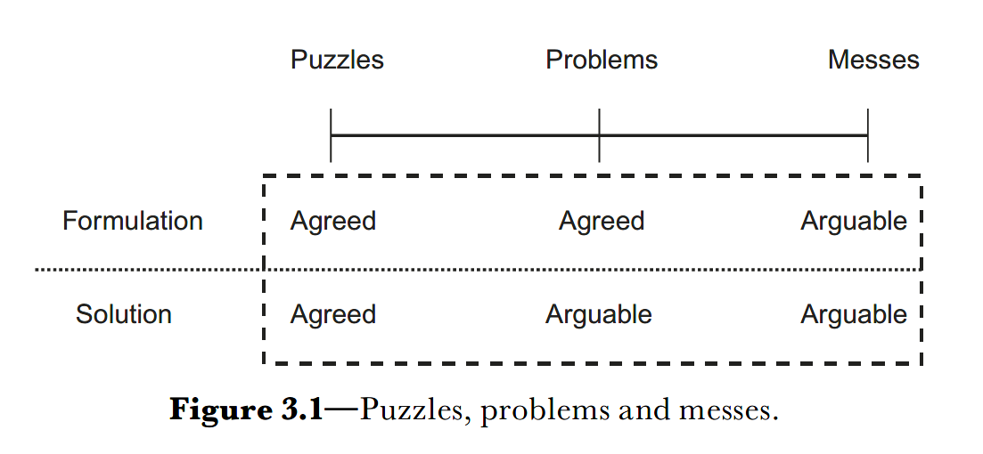

**The Principles of modelling**

* **Pidd’s Principles**
* **Model Simple, Think Complicated**
  + Simple model gives many more better insights.
  + Einstein model should be as simple as possible, but no simpler.
    - Certain amount of detail you cannot take it out if you keep richness
    - You simplify situation and get to point where you can’t simplify anymore
    - Taking off the layers of onion, Sean thinks this is misleading, sometimes you need to rebuild the onion in that you look haw far you can go for it to make sense. And come back to get the level of richness you want.
    - Process of abstaraction & what to leave out: start with identifying critical things to begin.
    - Gun example: we reduced it to trigonometry exercise. It didn’t realy stand scrutiny because we didnt include the relevant real world things like wind and weather, air resistance, turning of earth. These can also be included depending on the level of detail and purpose.
    - It is a question of going back as far as you can and work out what additional detail you need.
  + Combination of simple model and ability to consider and manipulate that model in a complicated way.
  + It is all about to think about consequences of the model in a relatively complicated construct. That is rebuilding onion.
* **Start Simple and Elaborate**
  + Onion metaphor is valid for this principle.
  + Add real basics and add detail as go along.
  + Doesnt mean: think about simple parameters and add parameters.
  + Does mean: think about simple set of parameters build the model and add them. You elaborate as you go along not the assumption list in the beginning.
* **Divide and Conquer**
  + Western scientific method is to take a problem and break it down into subproblems until you address each. Then try to infer from these each of subproblems.
* **Methaphors, Analogies and Similarities**
  + Easy to communicate & thinking. OR in action: how you might site a distribution center based on a requirement and need: Metaphor of center of gravity. A simple model has map, in it 5 cities. Has own specific needs. Model simply to find the center of gravity of cities based on needs. You can do it phscially using weights in a string. You can do it music using some maths.
* **Don’t fall in love the with data**
  + M&S require and produces data. Essentially we represent real world. Do not give too much validity something you created.
* **Modelling as Muddling**
  + It is all about learning as you go along. Getting hands dirty. Descriptors in MS it gives this. Ability to try things out in a virtual world that you can’t do in real world. Playing with reality. Flight simulators.
* **Some additional ideas…**
* **What is it for?** Never loose sight of why you’re modelling. It is only against purpose you can judge its utility and validity. If you misuse the model you go into hot water. Do not use models out of its area of validity. Ordnance survey map: just use it as far as it has level of detail. If you seek beyond this purpose it will harm you, not help you.
* **What is missed out?** Modelling is abstraction process. We are representing something. Context in which model is engaged. Pidd: Context was everything you decided not to model. There will something not in the model. You need to understand those as the thing you take to model.
* **Is it useful?** Does it help me think through the problem situation.
* **Am I learning something?** Difficult consideration. You get insight of real world. You need to continually cross reference that you do is a valid in real world. You do not know whether you’re really learning anything. Leap of faith: between what happens in model and what happens in real world.
* **What am I using it for?**
* **What should I not use it for?**
* **Models and Simulations**
* A model is a physical, mathematical or otherwise logical representation of a system, entity, phenomenon or process.
  + Abstraction and clear purpose necessary in the light of some context.
  + Like mathematical models: They can be articulated / interpreted in the language of mathematics and “run” (implemented on paper or on a computer).
* Simulation takes this model to see what happens over time.
  + Simulation shows what might happen in my model world (given model assumptions and abstractions).
  + Then insights on real world can be extracted.
  + Gun example: look consequences over time. Where shell might land overtime.
* There is no big difference.
  + Model is the artifact.
  + Simulation is the act of instantiating that model overtime.
* **Features of a System**[1] **Modelling:**
  + They in some way represent a thing or concept, without actually being it themselves.
    - Testing Formula car at wind tunnel in Trivium. Physical representation of pist is built there
    - They allows us to do something which we couldn’t otherwise do. Otherwise we wouldn’t need to bother with the MS that involves experimentation or communication. Simulation is allows to do that in virtual world in a safe way. Simulate effects of nuclear explosion.
    - Bikini Atoll real nuclear tests-this way is finished. Now it is done in virtual world.
  + They allow us to express and **communicate** something which is difficult, or impossible, to directly observed, e.g. an idea or concept.
    - Experiment in virtual world overtime then communicate insight.
  + They are created by us to achieve some **purpose** (generally beyond just communication), which cannot be easily achieved through access to the thing itself.
  + They often include some **assumptions** or **omissions** in their representation of the real world. This can be thought of as **context.**
* **Models and Simulations: Consequences and Confidence**
  + A simulation is, in essence, a method for investigating a model.
    - A simulation is hence **the consequences of a model** in some sense.
    - Given a model, we can establish some **set of possible consequences** of that model
    - Often (normally) there is no tractable “solution”.
    - Buying a car.
      * building a model, write down every expenditure.
      * Experimenting the model: look to the possible consequences of model overtime. Instantiate in a spreadsheet. Look in two months whether you have a viable economics for the household. Look to shocks, gas goes up.
      * Consequence will be expressed in numerical terms since this is simple model like artillery shell.
  + A simulation allows the exploration of the properties of a mathematical model where analytic methods are unavailable
  + Allowing us to relate **outcomes to assumptions**.
    - Simulation allows us to compare possible outcome set to the assumptions. Given that set of assumptions what might happen.
  + Very often the **implementation of a model over time.**
* **The Activity of Modelling and Simulation:** 
  + **What happens in a spreadsheet?**

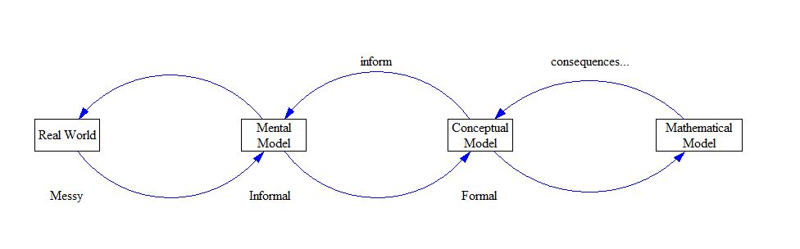

* *Step 0: looking cumulative cash flow overtime. My purpose to find whether I can afford this.*
* Step 1 - Enter data (salary, expenditure, savings, interest rates-mortgage etc.)
* Step 2 – Enter Relationships (ins-outs)
* Step 3 – Generate Outputs (results of steps1-2)
* Step 4 – Draw conclusions (car affordable or not)

*What about….* Do not forget half-steps. Because the very simplicity allows us to do quite

complex things without worrying too much about what we’re doing.

* *Step 0 – What are we trying to do?*
* *Step 0.5 – What Data to Collect?* 
  + Collect relevant data. General feeling of more data better is problematic. Pidd: Tendency to use large amount of data when not needed to build simple model might suffice.
* *Step 1.5 – What relationships and why?*
  + Top level: Spreadsheet being a model. You might be averaging overtime. You might take interest level. In fact you are modeling each of these individual steps. Be clear of the level of which that modelling is happening. Sometimes there is level between the top level output and data where we manipulate at a individual level.
* *Step 3.5 – What is the relationship between outputs (of the model) and conclusions (about the real world)*
  + How do I have confidence that the insights from model are useful about real world.
  + We can validate our budget model (in general hopelessly optimistic) against previous months. This is test of representing historical evidence.
* **Modelling and Simulation- Conclusions**
* Models are chosen representations of reality…
* Simulations generate possible consequences…
* Allowing us to draw conclusions…(whether model is useful in real context)
* Which we can consider and test (in some sense).
* Purpose?
* Relationship to reality?
* Fidelity? How much detail to go
* Utility?

Covid: assumptions, many models available. If we do nothing, this is the worst that can happen. Decisions based on models

* **Setting Expectations: What expectations to have in a Covid modelling exercise?** 
  + This model can inform your decision making. Somehow you’ll be more confident with the model. Support by evidence which are validated against reality.
  + **Relate to purpose, data availability, nature of the problem…**
  + **Case study** – Modelling the Coronavirus, how we use model: In covid, decision makers needed models to guide to say this is right or wrong. In reality we rarely get to this. There are models which try every each of below purposes, not true.
    - Explain something?
    - Predict Something?
    - Tell us how to behave?
* **Model verification and validation (used a lot in simulation literature)**
  + **Verification** – have I built it right? Doing what I say I am going to do. Error free. Have I included key relevant data into my budget model?
    - Technical activity, error free, correctly capturing my conceptual model
  + **Validation** – have I built the right thing? Does it help me in decision making. Jay forrester. Field of system dynamics. Model validity is being you can only judge a model validity in the light of whether it gave you insights you wouldn’t have had if you didn’t use the model. He is trying to get , has it improved the situation?
    - Much harder… Does it correctly represent what I wanted it to represent?
      * Sometimes this will be difficult / impossible to understand, depending on the subject being modelled…
      * Future combat system?
      * Conflict scenario?
      * How do validate combat modelling? In future scenario we use war gaming extensively. We can only validate components based on history or technical evidence. We have a probability of defeating tank at a certain range and armament. In terms of overall validity of model-->very difficult to do.
  + Extended form of DDI model.
    - From conceptual model he Sean put some working model (spreadsheet, epidemic or combat model)
    - He shows the steps of
      * verification: did I built it right?
      * validation: is the model useful rep of reality.

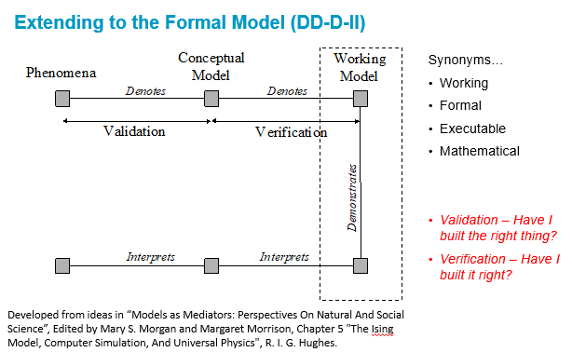

Covid article:

* Disease modellers struggle against misuse of models.
* Epidemiological models-imperfect:
  + They take into account everytihng but breaking rules. Positive students do not quarantine thmeselves.
  + Models are sensitive to data and assumptions.
  + Modeling in disease is difficult, providing answrs often there are none
    - Assumptions about virus biology, human behavious in time limit.
  + Modelling efforts for scenarios to reopen the campus
  + Reproduction number of covid.
  + Pandamics pushing the utility of models to breaking point.
  + İrrationality of human behaviour models need to mirror.
  + For decision makers: models say something, but not everything.
  + Data is wrong: math disease modeller Wu: numbers officially declared at the beginnig were wrong when we look to the spread rate.
  + Spread rate was huge and large percentage of undetected.
  + Unobtainable numbers: no knowlegde on parameters. modellers get numbers from SARS, but these 2 were different.
  + İnitial numbers coming from china-3 things: spread was 2 times faster than SARS, spread before symptoms,
  + Stat tech to estimate factors of transmission: not owrked for covid. New approaches needed.
  + Even with imperfect models and incomplete data sars-cov-2 crossing borders rapidly.
  + Modelling role in pandemic decision: establishing that there is a threat.
  + Modelling is not a prediction like weather forecasting. Forecasting a hurricane, and taking measures does not affect hurricane path. But in transmission of disease people actions have affect.
  + Models are built not to forecast but to way of understanding a process.
  + Purpose of model was to see if intervention could work, not to predict the cases in coming months.
* Models-rep of reality: spread of a virus through a population.
  + İnput features: length of virus’s incubation period, how long people stay infectious, num of death of given cases,
  + Algorithm in model relate all those, manipulate them appropriately, and output that represent some consequent behaviour of system-virus spread as reflected in the number of cases, hospitalzations, deaths or some other indicator.
* To understand pandemic two well-established approaches to quan ep modelling:
  + Models split population into Susceptible, Infected, Recovered, for long incubation of covid Exposed. SEIR Model, but this is still context-depend, on each ind health history, etc.
  + Agent-based models: it doesnt average across people, but rather simulate individuals, interactions, how virus may affect them if they get infected. More data required.
  + Asymptom ind responsible for %80 infections.
  + These models make projections, not predicitons, based on assumptions tah nmay change in a night.
  + İnsights: contact tracing is not enough to contain disease. Other show testing importance.
  + Imperial college london: projected 0.5M people saved by agent based model. Hypotetic, but useful, shows the usefulness of actions.

**Unit 3: Problem Structuring Methods**

* **Aim:** To consider how to model complex problem contexts – where the problem itself is perhaps not agreed (wicked).
* Tools to be used in structuring the problems.
* ***Unit 3.1***
* Introduction to Systems Thinking:
  + Notions of system; System Models; Context, boundary and perspective.
* Problem Structuring and Soft Methods:
  + Rich pictures, Pig Diagrams and Context Diagrams to enable the capturing multiple viewpoints and complex structures.
* ***Unit 3.2***
* Introduction to “soft” systems methods such as:
  + SSM, Influence Diagrams and Qualitative System Dynamics, Cognitive mapping
* Case study – Whitehaven, a new coalmine in Cumbria.
* Probllem types:
  + Puzzles-->Problems--> Messes (Wicked), where either formulation and solution is arguable. This is about exploration, trying to understand perspectives.
  + Tools will help to identify those.
* We must recognize the bias inherent in our thinking.
  + Soft system approach: we look from other POV. Easy to look from our own POV and draw hasty conclusions. But if we look from others POV we can reach consensus.
  + Military thinking: this soft. The way military and power work is different. It is all about imposition of will. Certain degree this is the case. But most enduring solutions have some sense compromise.
* Formal view of model and its relation to problem types and view
  + Mapping criterion: describe a thing: is it agreed?
  + Reduction criterion: depends on viewpoint, what to leave out?
  + Pragmatic criterion: for a reason: useful to whom?
* Lots of MS&OR focused on hard things during and after WW2. Optimization, logistics etc. Then some realized the messy things that these methods cannot applied. To many perspectives, stakeholders. Soft system come this point.
* Modelling in messes ***What about when we see different problems?***
  + ***DDI become disconnected:*** 
    - denoting phenomena problem, prevent a robust conception of model.
    - Demonstration of consequences will be problematic.
    - Interpretations depend on the perspective.
* Cumbria coal mine case:
  + Wicked problem, perspectives: environmental groups, company, job opportunity.

**System Thinking**

* System:
  + - sets of related parts.
    - Definition is not so useful because you get so many.
    - It is more about characteristics.
* Thinking ABOUT systems
* Thinking in a SYSTEMIC way
* Difference between systematic and systemic:
  + Systematic: to do something with a system. I have a systematic approach to something. I have a logical and structured way of doing something.
  + Systemic: means to recognize the systemness of something. So I am thinking systemically, I am recognizing the systemness in the problem that I am considering.
* **Skyttner definition**:

“A system is not something presented to the observer, it is something to be recognized by him. Most often the word does not refer to existing things in the real world but rather to a way of organizing our thoughts about the real world.” **“General Systems Theory”, Skyttner, 2001**

* + It is useful for us to group things together into sets which we can describe as systems. So we have a sensible conversations around them.
  + You might argue that in nature these systems exist like solar system. But it is relatively arbitrary grouping of objects around pretty unimportant star somewhere in the Virgo Supercluster.
  + So systems are useful way of organizing our thoughts about the real world. Then we understand where the linkages lie. How things interact. It is a way of seeing and thinking.
  + Key thing in system thinking is try to see the whole in its context. How things relate together.
* Recognising wholes, linkages, interactions within some unified whole
* A way of seeing…
* **Seeing Systems…**
  + **Cockpit:** there are communication systems, navigation systems, hardware system for steering control,
  + **Airplane:** When we come to context, bigger-or super system we see airplane. Cockpit become subsystem of this airframe.
  + Three dimensional air traffic control situation: we have now multiple airframes. Whole trying to safely land.
  + Broad transportation system. Coming from railway to get airline.
  + Military people taught to think 2 up and 2 down. Good idea to think at least in that sort of level.
    - * + Technology
        + People
        + Processes…
        + Other systems

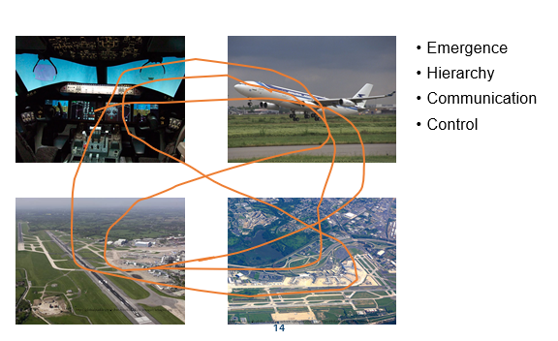

* This brings us to number of notions.
  + **Emergence:** Characteristic or observable thing you can see at a level of systems observation. But is not actually phsically present in any of the ones below it.
    - **Human body**, made up lots of bit and they all work together to create this phenomenon we called life. There is no one bit that holds it. But if you take any some of those bits away it’s going to stop quickly.
    - **Water:** is wet and has temperature. But there is no in individual hydrogen or oxygen other than something to do with energy.
    - These things are emergent. They come about at certain level. Because of the interaction below.
  + **Hierarchy:** We have super and subsystems.
  + **Communication:** Within hierarchy, flow of information and communication.
  + **Control:** We’re interested in these because we want to control it to make it useful and make it safe. Whole system of airplane: thorny problem to address.
* **Perspectives:** below synonyms. How you see the problems really comes from your perspective of the world. That linked to all of those notions.
  + viewpoint
  + angle
  + aspect
  + attitude
  + direction
  + frame of reference
  + outlook
  + perspective
  + point of view
  + How you see a “problem” can define it from your “perspective”.
* **Formal definition of system**: set of bounded objects (interacting elements).
  + **Notion of boundary:** They interact and have boundaries. Boundaries are important. It maybe arbitrary, maybe we define. It allows us to say that’s our system, everything outside we consider them part of other systems, everything inside are our subsystems. Then I can look interactions.
  + Notion of boundary is important when you get into management system. Because boundary is that bit of system you think you can manage.
  + System engineering term: getting the boundary right is really critical. It is the oundary which defines control and responsibility.

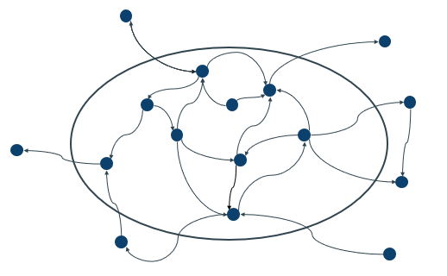

**System Models- Context, boundary and perspective**



* Conventions
* Relationships
* Boundaries
* Abstraction
* Simplification
* PURPOSE
* ***USEFUL!***
* Modeling a problem is not a system.

**Some Tools on problem structuring methodology –** methods to assist or think about in “finding out” about the “mess”.

Be careful the tool bias, you tend to make the problem fit at all.

Software for casual loop diagrams, cognitive map available but you can do it with pencil and paper. .

**The Big Picture**. Rich Picture – Making “sense of the mess”. With 1st step identify who stakeholders might be.

Gives very high level view of the problem space.

Gives different views on mess.

Introduced by Peter Checkland, developer of Soft System Methodology (SSM) in 1960s.

* Conversations show us that everybody says something slightly different.
* Bringing mess on a paper make everybody’s viewpoint explicit. There is assumption on openness. If I hide my views, there is no mean. Different viewpoints on Whitehaven, I can start with identifying interactions and view points. Take it and draw a messy picture of what’s going on. Make your thinking explicit both to yourself and others with whom you wish to communicate.
* **1st step of problem structuring intervention**: get it all down on a piece of paper. Don’t be uncomfortable with drawing. If so, do it in power point. But Sean encourages to embrace the mess, that is part of problem, Checkland always use hand drawn pictures. Deliberately, he says that it is messy. It is real. It is not nice straight lines.
* Rich picture for Whitehaven. It might be; (doing different views, different perspectives included)
  + Geographical:
  + Picture of relates to planet
  + Driven by specific users,
  + Time based
* 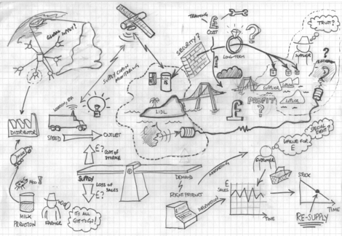
* Telephone helpline situation
* 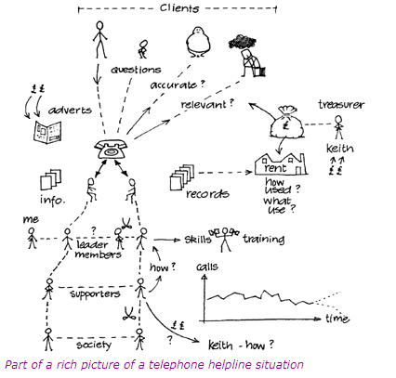
* *Image taken from http://systems.open.ac.uk/materials/T552/pages/rich/richAppendix.html*
* Embrace the mess – my advice would be not to try to go for PowerPoint “tidy”
* Invent your own symbols, but use obvious ones too…
* Obvious conventions:
  + Conflict is represented by cross swords.
  + People…
* Drawing the Rich Picture forces you to really get “under the hood” of the problem.
* The complexity of human affairs is best illustrated…
* “Picture paints a 1000 words”
* Less ambiguous?
* Better communication?
* “The problem”…
  + Identification
  + Agreement?

**Stakeholder Interests**. Pig Diagram – Establishes stakeholders and interests, **Exploring different perspectives in a problem situation**

1st step defined who the stakeholders. This step brings us to Pig model because this allows think about what the stakeholders perspectives might be and why they’re important.

Pig is many things. For child it is a story character in a book. To a wolf pig is pray. To a farmer it is a source of income and livestock. This allows us to identify stakeholders and their different perspectives.

Then we can go back and iterate our rich picture. And make changes.

You tend to build a sort of artifact set where things grow together. And you may decide that actually you do not want to start with rich picture. You much rather start by identifying the various stakeholders. In Whitehaven for example, good to start with think about the various interest groups. What does it mean to them? Then it becomes seperate artifact that allows you to communicate with others based on perspectives.

* Draw the system, radial diagram in focus (pig) or problem in the centre…
  + Ex: Cumbrian mine. Stakeholders: residents, council, environmental groups, company. Identify as many as you can.
  + But in some point abstraction will play. Dont forget it is representation. You’ll simplify, maybe grouping, or not include the less important things.
* …so you need to decide what the pig is, encouraging discussion on the system boundary.
* Identify each stakeholder in the system/problem and add them around the pig (text or cartoon), linking them with a line
* Annotate the link with the perspective of the stakeholder

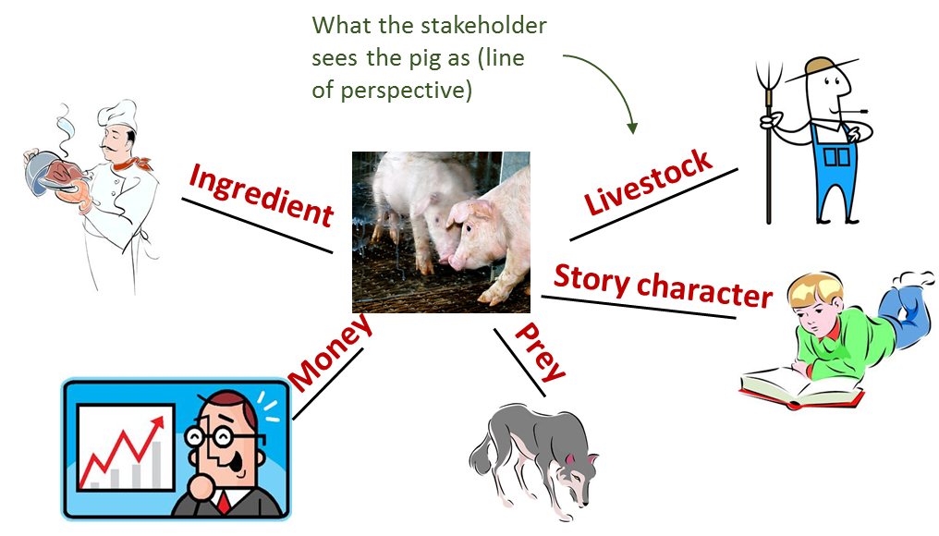

*Name arises from the original model developed by* ***Gareth Morgan*** *who demonstrated the model’s concepts by considering a pig as the focus.*

*This is a great example of a model as a metaphor!*

**Stakeholder Interests- Developing the Stakeholder Perspectives-Formal**

* Taking the initial stakeholder perspective with interviewing, it is then possible to expand each stakeholder’s view and motivations.
* This can be done through a structured set of questions applied to each stakeholder in turn:
  1. How do each of the stakeholders see the system of interest?
  2. What really matters to each of the stakeholders regarding the system?
     + Form this as a line of perspective
  3. How might each stakeholder define or describe their own current position on that line of perspective?
  4. Where might they prefer to be in terms of options?
  5. What would seem to be make their appreciation of their position better or worse?
  6. What, if anything, can you or they do to affect any aspects of the situation?

At the end of the day there will be an artifact, a picture, backed off with analysis.

These two are fundemental ones.

* Rich pictures were top level perspective
* Pig diagram-Individual stakeholder identification and perspectives.

**Influence and Control**. Context Diagram – Putting it on the context of other systems and relationships

* Systems engineering artifact. It allows us to think about where influence and control exist within the system.
* Think of it as a target with a system of interest-SOI in the middle. SOI will be part of some wider system of interest-WSOI--> in environment (E)-->in wider environment (WE).
* Lines are important. If I am responsible for SOI in Orange, these are things I have influence and control.
  + SOI: Both influence and control. navigation system in aircraft. Aspects within that SOI will be subsystems.
  + WSOI is airframe: some influence no control. Aspects of it is air traffic control. I have some influence on. I might have some services.
  + Environment -E: no control and no influence, like weather. It strongly influences me.
  + Wider Environment: less of a hard boundary, like legislation.

For West Cumbrian company:

SOI: Mine,

WSOI: Local are and my business environment, political env.

E: Local and global opinion on climate issues.

WE: Global competition from China.

* From system engineer perspective it is useful to debate. Future artillery system range, SOI was artillery piece. In order to have an effect, they needed to control aspects of the ammunition which is not within SOI. It became important conversation between different teams to look at cooperation iot achieve broad capability effect. This tool could be useful to help to have this conversation. How the moving of the blobs and the establishment of the blobs are important.

* Context Diagrams are used to identify how and where the system of interest interacts and is governed by its wider context
* Is used in practice to enable refinement and definition of the system of interest’s boundary
* Follows a strict convention of rules that govern interaction between elements between and within each of the four zones
* Can become extremely complex with larger systems at high fidelity
* This in itself can indicate a need to simplify the system description

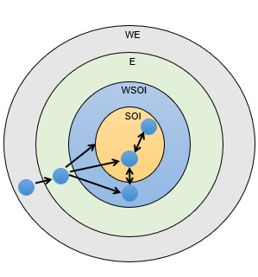

System of Interest (SOI): The SOI is the system in focus; where the decision maker has control and influence

Wider System of Interest (WSOI): Consists of interacting systems or elements, which can be influenced by the decision maker but over which the decision maker has no direct control

Environment (E): The context elements that have influence on the SOI but the decision maker has no control or the system has no outward influence

Wider Environment (WE): Factors which can affect the elements in the Environment, may represent needs and constraints of other systems and stakeholders

**Raci Matrix -** responsibility assignment matrix; describes the participation by various roles in completing tasks or deliverables for a project or business process.

RACI is an acronym derived from the four key responsibilities most typically used:

**R**esponsible,

**A**ccountable,

**C**onsulted, and

**I**nformed. It is used for clarifying and defining roles and responsibilities in cross-functional or departmental projects and processes.

* Whitehaven resident: high interest but low influence
* This matrix is to take the outputs from stakeholder map, pig diagram.

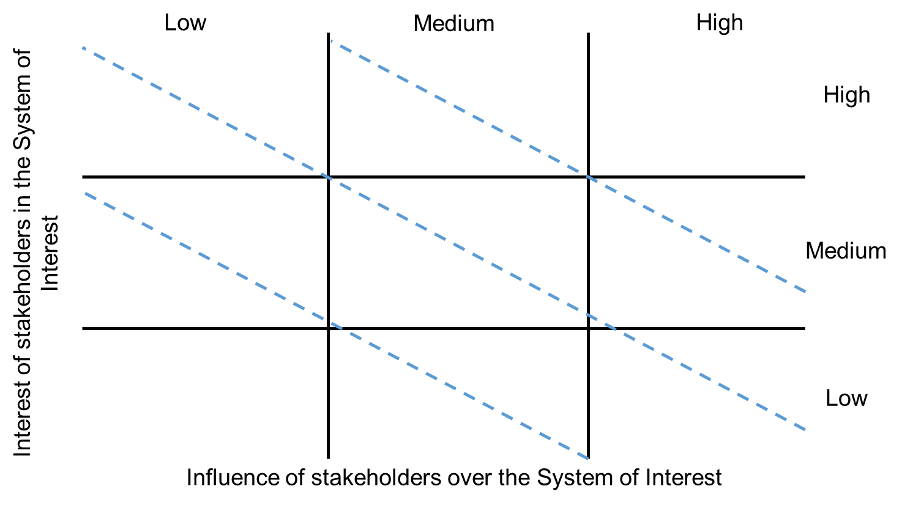

Rich picture - big picture

Pig diagram - stakeholder

Influence and control - Components of the system (maybe abstract or physical)

**Relationships**. Concept Map

* We do it but dont name. Ultimately we group concepts and link them with effectively verb type structures. Below example shows what stakeholders in problem system might be. I can use this map to communicate with you and say stakeholders have perspectives and interests in something which is problematic. They have different levels of power and influence for resolution. The resolution influences them in turn. There can be many potential resoutions. We can link money and unforeseens. Sideeffects. Some might be foreseen.
* **Concept Mapping – the transition from pictures to words**
* A way of ordering the complexity
* Using words and “linkers”
* Looking for points of leverage
* *Cmap Tools is freely downloadable from* [*Cmap | CmapTools (ihmc.us)*](https://cmap.ihmc.us/)

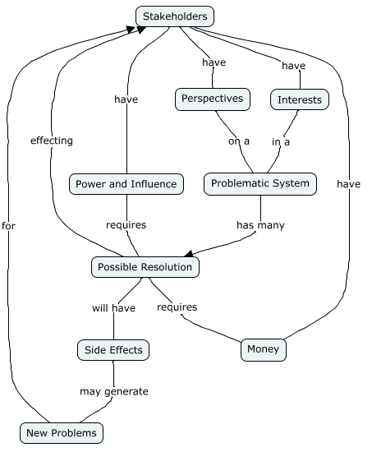

Pidd: cognitive mapping: use this structure to have conversation.

Form of influence diagram-similar to the ones used in system dynamics, chapter 7.

Eden Ackermann,Cropper see this as subset of cause maps of Fiol and Hull (1992).

The map consists of nodes, known as concepts, linked by arrow.

con2 - Live in town+not on campus leads casually con1- want a normal life + not living like student

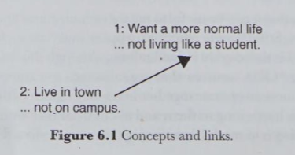

Concepts (nodes)

Concepts are ideas and issues that have some meaning for people involved, and expressed by words.

Sometimes a concept might include two poles, such: goal is normal life, second pole “not living like student” clarifies meaning of first.

Bi-polar concept: I wish to lead normal life, by which I mean that I do not wish to live on campus.

Bipolar concepts should be expressed action oriented. Want a normal life (is goal) and live in town express desires, this does not mean action will follow. Other factors may intervene. Another concept living 75£ a week. Only possible in campus. Both concepts are geared towards action. Interaction will produce result.

If the concept is clear without a second pole, use one pole. If ambigious use 2 poles.

Arrows (arcs)

* Arrows represent casual links between concepts. They show relationship between pair of concepts.
* The concept at the start-tail- is achieving the concept at the end -head.
* Higher end concepts (goals) sit at the end of the chain.
* Arrowhead with ‘-’ means there is negative casulty.
* Increase in the means reduction in the end.
* Second pole of the means concept is psychologically linked by person to the first pole of the end concept.
* Negative sign system is employed because concepts with two poles should be expressed with the desirable pole as the first. Person would prefer to stay in a hotel but also prefer a cheap hotel.

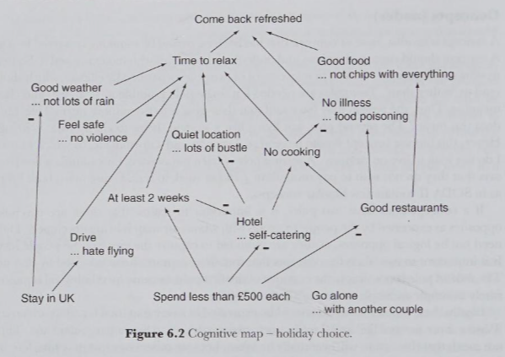

Getting started with cognitive mapping

Fran Ackermann, Colin Eden, Steve Cropper

* Cognitive mapping is a technique to structure, analyze, and make sense of problems.
* Or it can be used as note-taking method.
* Founded on Kelly’s theory of personal constructs. This suggests that we make sense of the world to predict how the world will be in future and to decide how we might act.
* Helps to understand client’s perception of problem.
* Represent how client thinks. Valuable for OR’s
* Technique’s ability to structure, organize, and analyze data enable both client and Ors to begin to negotiate a suitable direction forward.

How to map

* Account of problem is broken into its constituent elements-phrases of 10-12 words which retain the language of the person providing account.
* Treat those as distinct concepts, which are then reconnected to represent the account in graphical format.
* This reveals the pattern of reasoning about a problem in a way word cannot.
* Pair of phrases may be united in a single concept where the one provides a meaningful contrast to the other. Phrases are construct: meanig is retained through contrast.
* Distinct phrases are linked, each to related others, to form hierarchy of means and ends. This involves deciding on the status of one concept relative to another. There are number of categories or levels defined in a notional hierarchy that help user to make such decisions. Meaning is retained through the context.

Guidelines

1. Seperate sentences into distinct phrases. 10-12 word. Effective mapping: mapper has a way of sorting the concepts into types of concept. Idea of layers in a hierarchy to sort out concepts. Layers are simply goals, strategic directions, potential options.
2. Build-up the hierarchy. Structure of model. Place goals -profit- at the top of map and supporting this first with concepts indicating direction and further on with potential options.
   1. İdentify concepts which you feel are goals (desired by stakeholders, not options) at top of hierarchy.
   2. Goals:
      1. extracted from stakeholders body language; not-verbal.
      2. difficult to spot in text.
      3. points of integration and differentiation.
      4. Primary of interest, but maybe not certain in beginnig.
3. Watch out for goals. This will end up at the top of the map. Superordinate concepts.
   1. Ex: improved level of service
   2. Supporting these goals are strategic direction: local rep, centralised service, opening local offices. These directions are related to goals.

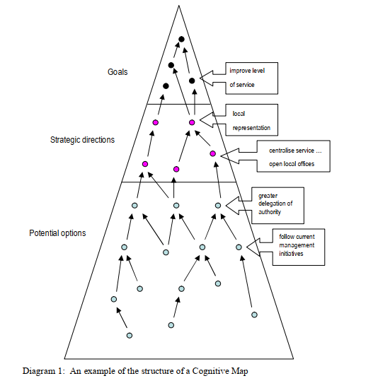

1. Watch out for “strategic directions” by noting concepts that have characteristic of: Long term implications, High cost, İrreversible, Need a portfolio of actions to make them happen, May require a change in culture.
   1. Potential options lead to directions and they lead to goals.
   2. The links joining the concepts together should be interpreted as “may lead to”.night may lead to light turn on.
   3. From text you get centralize service or open local offices, mapping need to highlight these contrasts since they represent significant choices. The concepts which form the basis of a map are bi-polar.
2. Look for opposite poles.
3. Add meaning to concepts by placing the concepts in the imperative form and where possible including actors and actions.
4. Retain the words used by problem owner
5. Identify the option and outcome within each pair of concepts.
6. Ensure that a generic concept is superordinate to specific items that contribute to it.
7. Helpful to code the first pole as that which owner sees the primary idea.
8. Tidying up can provide a better understanding to the problem.
9. Paper usage

**Cause and Effect**. Causal Loop Diagram

* Interesting because it produces feedback. Something reinforces or destroys behaviour. Fossil fuel: convention: I have concepts, link them with arrows.
* Production of fossil fuel influence the price: production level ups prices down and vice verca. Positive and negative effects. Putting all together I can understand reinforcing loops or potentially balancing loops.
* **How structure determines behaviour**
* A way of visualising cause and effect and how it determines behaviour
* Enables feedback thinking
* Vicious circles
* Virtuous circles
* *The Vensim Personal Learning Edition is freely downloadable from* [*www.vensim.com*](http://www.vensim.com/)

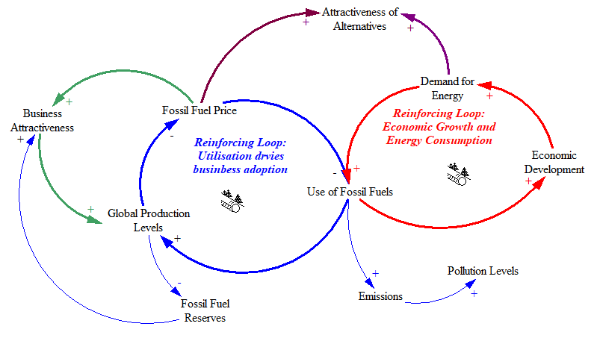

***Loop Analysis and Rules***

* *Arrows define the loop*
* *+/- define the type*
  + *+ is a reinforcing link: prod up- price down-use up, drives extraction of fossil fuels.*
  + *- is a balancing link*
* *Positive feedback – even number of “-”*
  + *Unchecked, exponential growth…*
* *Negative feedback – odd number of “-”*
  + *Damped, balanced*

Simply:

Add number of pluses and minuses

If you have odd number of minuses then your behaviour flip flops every time around and that gives you something which balances.

Even number of minuses you have something reinforces everytime it goes around. Gives you unconstrained growth.

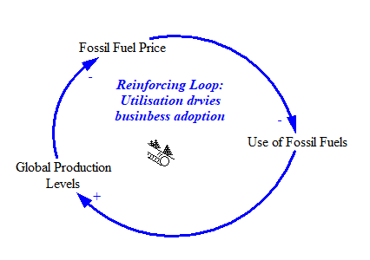

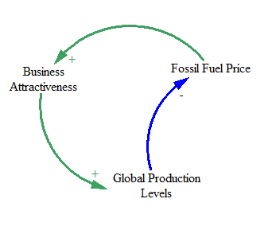

***Some “Takeaways”…***

* *No “Right Way” to use a model…*
  + *What is useful, not “doctrinal”*
  + *Metrics are…*
    - *Understanding (and ability to understand)*
    - *Communication (ease, both ways)*
    - *Utility (better view on perspective, agreement on problem)*
  + *NO SILVER BULLET!*
* *Best way is to try it (here, when it doesn’t matter!)*
  + *Tools*
  + *Case Study*

***Products***

* ***The Big Picture. Rich Picture – Making “sense of the mess”***
* ***Stakeholder Interests. Pig Diagram. Who are the stakeholders? What is their interest and influence?***
* ***Influence and Control. Context Diagram – further explore influence and interest in relation to other systems…***
* ***Relationships. Concept Map to start to put it into words…***
* ***Cause and Effect. Causal Loop Diagram to understand the cause and effect in the system…***

***A variety of methods to enable generation of understanding***

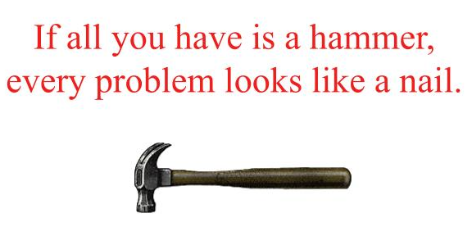 *The law of the instrument or "Maslow's hammer" is a cognitive bias that involves an over-reliance on a familiar tool*

Putting all those tools into methodologies.

**Unit 4: Multi-Criteria Decision Analysis**

**Here, we will consider situations where several, usually conflicting, criteria are of interest.**

* Value trees
* Scoring methods, including direct rating and value functions
* Criteria weighting, particularly swing weights
* Trade-offs, efficient frontiers and sensitivity analysis

**Unit 5: Decisions Under Risk and Uncertainty**

In this unit, we will look at decisions where risk and uncertainty play a major role.

* Decision trees
* Influence diagrams (decision network variety)
* Preferences, values and utilities

**Unit 6: Biases Affecting Judgement and Decision Making**

In this unit, we will look at various biases and their effect on decision making.

* Different examples of cognitive biases
* Different examples of behavioural biases
* When mitigation is possible

References

• Howard RA (1966) Decision analysis: applied decision theory. Proc. 4th International Conference on Operational Research, Boston, MA, pp 57-71.

• Howard RA (1988) Decision analysis: practice and promise. Management Science 34(6), 679-695.

• Phillips LD (1990) Decision analysis for group decision support. In: Eden and Radford (eds) Tackling strategic problems: the role of group decision support. Sage Publications, London.

• Raiffa H (1968) Decision Analysis: Introductory Lectures on Choice Under Uncertainty. Addison-Wesley.

• Simon HA (1957) A behavioral model of rational choice. In: Models of Man, Social and Rational: Mathematical Essays on Rational Human Behavior in a Social Setting. Wiley, New York.

• Von Winterfeldt D and O’Sullivan TM (2006) Should we protect commercial airplanes against surface-to-air missile attacks by terrorists? Decision Analysis 3(2), 63-75

Zeigler, Theory of Modelling and Simulation

1. **System:** Mind is a set of parts interacting in some way.Central idea: we have to model them to consider. This comes to point of mental models which enable interactions with the real world.